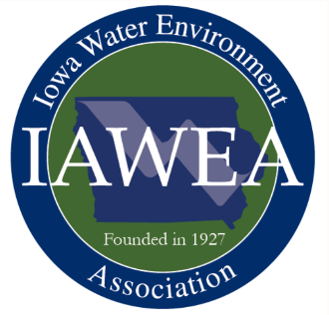**Call for Abstracts**

*IAWEA 2023 Annual Meeting and Technical Conference*

Waterloo Convention Center

Waterloo, IA

June 7-8, 2023

IAWEA’s wastewater conference connects wastewater industry professionals including engineers, utility managers and operators, industry service providers, and equipment suppliers. The conference includes over 40 technical presentations, 50 vendor exhibits, the annual recognition banquet, and lunches.

Please submit abstracts on suggested or other relevant Iowa technical topics for consideration by the program committee. Suggested topics include the following:

* Emerging Issues
  + Microplastics
  + Biofuel Generation
  + New Microbial Information
  + Pharmaceuticals
  + PFAS
  + Human Health Monitoring in Wastewater
  + Biogas Generation and RINs Credits
  + Innovations in Wastewater
* Watersheds
  + Stormwater
  + Nutrient Exchange
  + Sponsored Projects
* Operations
  + Operational Strategies
  + Energy Saving Techniques
  + Nutrient Removal Optimization
  + Nutrient Optimization for Small Systems
  + Industrial Pre-treatment
  + Resource Recovery
  + Biosolids
  + Case Studies
* Maintenance
  + Asset Management
  + Predictive Maintenance
  + Equipment Troubleshooting
  + Big Data/Analytics
* Utility Management/Administration
  + Personnel Management
  + DEI
  + Funding Strategies
  + Infrastructure Resiliency
  + Cybersecurity
  + Billing and 28E Agreements
* Collection Systems
  + Repair
  + Lining
  + I/I Reduction
  + Flow Monitoring
  + Case Study
* Laboratory Practices
  + Ethics and Data Integrity
  + Basics of Laboratory Calculations
  + BOD Discussion

All presentations are to be based on case studies, scientific data, and/or research and are not to be product specific. All sections must be completed below, and abstracts with blank fields may be declined. Please limit to a five page total with figures and tables added to end of file.

One, and only one, principal speaker can attend/eat the day of the presentation for free. However, speakers must register and pay to receive CEUs/PDHs. All speakers, free and paid, must register themselves for the conference. Abstract acceptance does not register you for the conference.

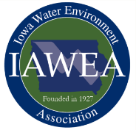

**Presentation Abstract Form**

**IAWEA 2023 Annual Conference**

**Waterloo, Iowa**

Presenter Name, Affiliation:



Email:



Address:



City, State, Zip:



Phone:



Presentation Title:



Abbreviated Title for Published Program (limit to 40 characters):



Preferred Presentation Length: 25 Minutes 45 Minutes

Presentation Topic Area (check all that apply):

Emerging Issues

Watersheds

Operations

Maintenance

Utility Management/Administration

Collection System

Laboratory Practices

Additional Presenters, Affiliations:



Brief Speaker Bio (maximum 100 words):



**Submit** at: <https://iawea.regfox.com/2023-iawea-annual-conference-abstract-submittal> Contact Patrick Brown at pabrown@dmgov.org with any questions.

Presentation Abstract: Fill-in fields below (feel free to provide additional information on last page).

Problem or Challenge (maximum 300 words):



Solution or Approach to Solution (maximum 300 words):



Conclusion/Recommendation (maximum 300 words):



Insert additional information (up to 2 pages) with figures or tables that help to further explain your presentation.