Call for Abstracts
2020 IAWEA Annual Meeting and Technical Conference
Davenport River Center
Davenport, IA
June 3-4, 2020

Deadline for submitting abstracts: January 17th, 2020.
IAWEA’s wastewater conference connects wastewater industry professionals including engineers, utility managers and operators, industry service providers, and equipment suppliers. The conference includes over 40 technical presentations, exhibits, the annual recognition banquet, and lunches.
Please submit abstracts on suggested or other relevant Iowa technical topics for consideration by the program committee. Suggested topics include the following:
- Challenges
- Collection Systems
- Compliance Issues
- Emerging Issues
- Industrial Pretreatment
- Infrastructure Resiliency
- Innovations
- Laboratory Practices
- Management
- Nutrients
- Nutrient Optimization for Small Communities/Small Systems
- Resource Recovery
- Watersheds-Stormwater Quality, Nutrient Exchange, Sponsored Projects
- Other

All presentations are to be based on scientific data and research and are not to be product specific. All sections must be completed below, and abstracts with blank fields may be declined. Please limit to a ten page total with figures and tables added to end of file.
Note, speakers can attend/eat the day of the presentation for free, but must register and pay to receive CEUs/PDHs.
Please complete the abstract form and submit online at www.iawea.org by January 17, 2019.

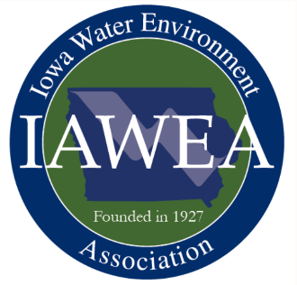
Presentation Abstract Form
IAWEA 2020 Annual Conference
Davenport, Iowa
PRESERVING IOWA’S WATER
Presenter Name, Affiliation:
Email:
Address:
City, State, Zip:
Phone:
Presentation Title:
Presentation Topic Area (Check all that apply):
Challenges
Collection Systems
Compliance Issues
Emerging Issues
Industrial Pretreatment
Infrastructure Resiliency
Innovations
Laboratory Practices
Management
Nutrients
Nutrient Optimization for Small Communities/Small Systems
Resource Recovery
Watersheds – StormwaterQuality, Nutrient Exchange, Sponsored Projects
Other

Additional Presenters, Affiliations:

Brief Speaker Bio (maximum 100 words):

Submit by January 17th, 2020 at:
https://iawea.regfox.com/2020-iawea-annual-conference-abstract-submittal

All sections should be completed. Abstracts with blank fields may be declined.

Questions? Send email to Jon Koch at jkoch@muscatineiowa.gov

Presentation Abstract: Fill-in fields below (feel free to provide additional information on last page):
Problem or Challenge (maximum 300 words):

Solution or Approach to Solution (maximum 300 words):
Conclusion/Recommendation (maximum 300 words):

Insert Additional Information (Please limit to ten pages total or seven additional pages for Figures and Tables). Feel free to add figures and tables in the forms below or convert to pdf and merge the files.
Figure 1.
Figure 2.
Figure 3.
Figure 4.
Figure 5.

Table 1.

Table 2.

Table 3.

Table 4.

Table 5.

