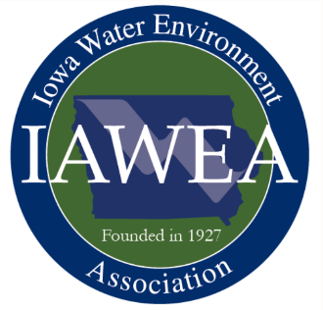**Call for Abstracts**

*IAWEA 2022 Annual Meeting and Technical Conference*

RiverCenter

Davenport, IA

June 8-9, 2022

Deadline for submitting abstracts: January 10, 2022

IAWEA’s wastewater conference connects wastewater industry professionals including engineers, utility managers and operators, industry service providers, and equipment suppliers. The conference includes over 40 technical presentations, exhibits, the annual recognition banquet, and lunches.

Please submit abstracts on suggested or other relevant Iowa technical topics for consideration by the program committee. Suggested topics include the following:

* Emerging Issues
  + Challenges
  + Microplastics
  + Biofuel Generation
  + New Microbial Information
  + Pharmaceuticals
  + PFAS
  + Covid in Wastewater
* Watersheds
  + Stormwater
  + Nutrient Exchange
  + Sponsored Projects
* Operations
  + Operational Strategies
  + Energy Saving Techniques
  + Nutrient Removal Optimization
* Management Issues
* Collection Systems
* Industrial Pre-Treatment
* Laboratory Practices
* Resource Recovery
* Nutrient Optimization for Small Systems
* Innovations in Wastewater Treatment
* Infrastructure Resiliency
* Cybersecurity
* Big Data/Analytics
* Challenges
* Nutrients
* Funding Strategies
* Biosolids
* Asset Management

All presentations are to be based on scientific data and research and are not to be product specific. All sections must be completed below, and abstracts with blank fields may be declined. Please limit to a five page total with figures and tables added to end of file.

One, and only one, principal speaker can attend/eat the day of the presentation for free. However, speakers must register and pay to receive CEUs/PDHs. All speakers, free and paid, must register themselves for the conference. Abstract acceptance does not register you for the conference.



**Presentation Abstract Form**

**IAWEA 2022 Annual Conference**

**Davenport, Iowa**

Presenter Name, Affiliation:



Email:



Address:



City, State, Zip:



Phone:



Presentation Title:



Abbreviated Title for Published Program (limit to 40 characters):



Presentation Topic Area (check all that apply):

Emerging Issues Nutrient Optimization for Small Systems

Watersheds Innovations in Wastewater Treatment

Operations Infrastructure Resiliency

Management Issues Cybersecurity

Collection Systems Big Data/Analytics

Industrial Pre-Treatment Challenges

Laboratory Practices Nutrients

Resource Recovery Covid in Wastewater

Asset Management Funding Strategies

Biosolids

Additional Presenters, Affiliations:



Brief Speaker Bio (maximum 100 words):



**Submit by January 10, 2022** at:

# <https://iawea.regfox.com/2022-iawea-annual-conference-abstract-submittal>.

# Send email to Bob Ranson at branson@marshalltown-ia.gov if there are questions.

Presentation Abstract: Fill-in fields below (feel free to provide additional information on last page).

Problem or Challenge (maximum 300 words):



Solution or Approach to Solution (maximum 300 words):



Conclusion/Recommendation (maximum 300 words):



Insert additional information (up to 2 pages) with figures or tables that help to further explain your presentation.